|  |  |
| --- | --- |
|  | -ROCKETLAUNCH!  *THE MANUAL* |

# **Inhalt**

Inhalt 1

1. WHAT IS IT 3

2. HOW TO USE ROCKETLAUNCH 3

The Upper Bar 4

The Source File view 4

The Templates view 5

The bottom panel. 5

3. TEMPLATES 6

4. ADVANCED SETTINGS 6

Create a Quick Access Shortcut in Explorer 7

Create an Outlook Folder 7

Count Words 7

Open folder once ready 7

Send a notification once ready 7

Close application after creation 7

5. HOW TO INSTALL ROCKETLAUNCH 8

6. WHAT I AM WORKING ON 8

Downloads and Drag&Drop views 8

Count Words 8

Localization 8

Have a settings file 8

Make it quicker 8

7. KNOWN BUGS 9

Lack of testing 9

Autodeleting exe 9

False positive 9

# WHAT IS IT

A program to create new projects, in the right place, super super quick and how I want it. It is designed to follow standard Skrivanek GmbH practices, adjust to whatever user input error, and be as out-of-the-way as possible. Nobody likes it when software UI is needlessly annoying.

On the technical aspect, it is a set of Powershell scripts, written in imperative style, using Windows.Forms as GUI, with the main one compiled into PS2EXE (which simply wraps the Powershell code within C# code).

# HOW TO USE ROCKETLAUNCH

|  |  |
| --- | --- |
|  | Upon opening “Start Rocketlaunch.exe” you may see this window. Rocketlaunch pulls files for project creation from clients emails, but it depends on Outlook for that.  It also needs to also analyse each mail to find those relevant for new projects. (Ex: Mails with no attachments are pointless to pull from) |

Once loaded, the main app window will appear. It is made up of four elements:

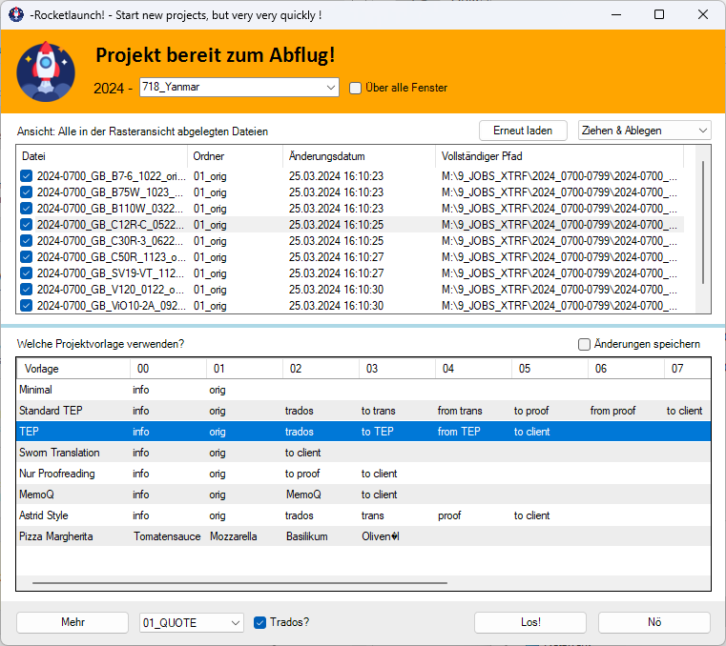

## The Upper Bar

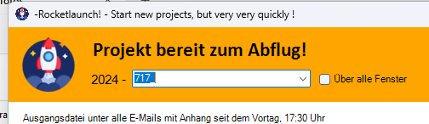

You can enter the project code here. By default, Rocketlaunch tries to predict the number of next projects, and offers several more just in case. It tries to predict as well client name from the last email received with attachments.

When the checkmark is checked, the whole app remains above all other windows, which can be handy in some situations – For example you need to copy a project code from a client.

The year is automatically appended to it, as well as missing zeros. For example, if you enter the project number “14_Client” it will create a project “2024-0014_Client”

## The Source File view

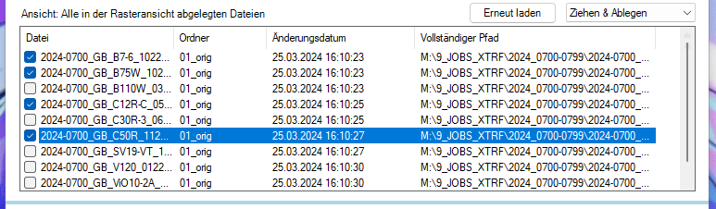

The menu allows to select a different source for files to be included in the project :

|  |  |
| --- | --- |
| **VIEW** | **DETAILS OF THE VIEW** |
| Outlook | This view loads all the emails received since the last working day, 17:30 – It automatically skips to look up since Friday 17:30 if the app is used on Monday.  You can select an email from which the application will get the attachments of, to include in the new project. By default, the last email is selected. |
| Downloads | This view loads all the files created the same day as today – This way you can include files you previously downloaded to get a look at. You can include files in the new project by checking them with the checkbox |
| Drag & Drop | This view displays all files which have been dragged onto the source file view, even when it was displaying another view. You can include files in the new project by checking them with the checkbox |

You can load the view anew with the reload button. In the case of the email view, it fetches new emails as well, which may be slow.

The blue bar below the Source File view allow to resize said view compared to the template view.

## The Templates view

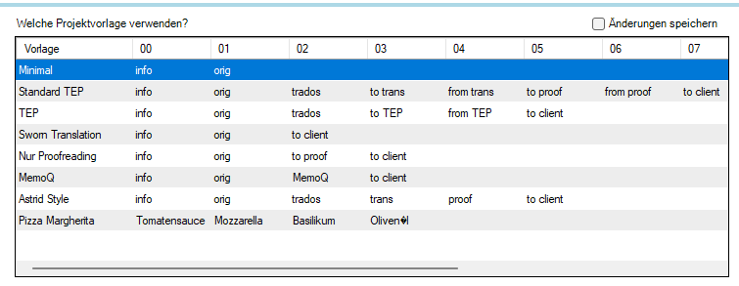

This view loads the template CSV file in the documentation folder. It offers all the directories structures described within it. Each folder in the selected line will be created, with folder number as display in the column.

You can double-click on any cell to edit it on-the-fly as you require it in the moment. It will not be saved unless you check the upper-right checkmark. In which case the view will overwrite the original template file.

Upon project creation, the project creator will assume any folder starting with “00” is the info folder, and “01” the one for original files.

## The bottom panel.



|  |  |
| --- | --- |
| **BUTTON** | **DETAIL** |
| “More” Button | Open settings. These allows to decide what is done during the creation process, one-time only. The defaults are fine. |
| Outlook folder Box | Specify where in Outlook a project folder should be created. The last element allows to choose to not create any outlook folder. |
| “Trados?” Checkmark | when checked, starts the Trados project creation assistant and fills it wherever possible, once everything else is done. |
| “Go!” Button | launches the actual project creation, with all of the information and settings entered. |
| “No” Button | closes the app, without doing anything. |

Enjoy 😊

# TEMPLATES

The template file is a CSV file which can be opened with Excel. It starts with “sep=;” to signify to Excel how to open it – Do not forget it when creating a new one, as the application skips the first line to not display it.

Folder structure is arranged in lines, like in the application. Start the line with the template name (which will be ignored when creating folders), and simply list the folder names. When creating a new project, the application will append automatically folder number in front of it.

The application looks into its own documentation folder, for the file named “Project templates.csv”. The content of that file is as follows:

|  |
| --- |
| **Rocketlaunch/documentation/Project templates.csv** |
| sep=;  Minimal;info;orig;;;;;;  Standard TEP;info;orig;trados;to trans;from trans;to proof;from proof;to client  TEP;info;orig;trados;to TEP;from TEP;to client;;  Sworn Translation;info;orig;to client;;;;;  Nur Proofreading;info;orig;to proof;to client;;;;  MemoQ;info;orig;MemoQ;to client;;;;  Astrid Style;info;orig;trados;trans;proof;to client;;  Pizza Margherita;Tomatensauce;Mozzarella;Basilikum;OlivenÖl;;;; |

# ADVANCED SETTINGS

|  |  |
| --- | --- |
| These are exposed through a dialog showing up when the “More” button is clicked in the Main window.  They are not saved, the idea behind that they are needed only for edge cases more frequent than the “Trados” checkmark.  There are additional buttons for help as well, opening this documentation, or allowing to send me an email.  There is also an “About” tab. |  |

## Create a Quick Access Shortcut in Explorer

|  |  |
| --- | --- |
|  | When checked, the newly created project folder gets pinned on the Quick Access panel on the left in the Explorer file manager. |

## Count Words

Generate a CSV analysis file which count words in the included files. This does not work for Powerpoint and Excel, is slow because it depends on Office, and PDFs are unreliable at best.

Also automagically copy the total amount in the clipboard.

Not ready yet and not sure how useful.

## Open folder once ready

Once done, opens the newly created project folder with the file manager. You can now work in it.

## Send a notification once ready

|  |  |
| --- | --- |
|  | Once done, send a notification through Windows notification system.  May be useful when working remote and everything is slow through the VPN |

## Close application after creation

Once done, close the application.

# HOW TO INSTALL ROCKETLAUNCH

Double-click on “Install Rocketlaunch” – This will create on the desktop a folder and a shortcut to executable, and notify you once done.

Simply double-click on shortcut or on the executable in the folder to start the application. You can pin it or the executable to taskbar – it is not done automatically because Microsoft actively discourages that.

Nothing is done to folders like “Program Files”, these require admin permission, and I am not comfortable doing anything automated there either. Probably, neither does the antivirus.

To uninstall it, delete the folder.

# WHAT I AM WORKING ON

All of these actions are still in the making. Give me some time!

## Localization

Allow to change language of displayed text based on user language, and add a dropdown to select another.

## Make it quicker

Quicker! Retrieving emails Is too slow.

# KNOWN BUGS

## Lack of testing

Not sure what doesn’t work correctly yet. This one is fairly simple and does not rely too much on peoples to function.

## Autodeleting exe

The antivirus doesn’t like random executables and may delete the file randomly. Cant do anything about that.

## False positive

The antivirus does not like random executables and may freeze execution and display a window, asking whether to deny or allow. Just click allow. I cannott do anything about that.